**Experiment No. 1**

Aim: To study RJ45 and CAT6 Cabling and connection using crimping tool.

Requirements: RJ45 connector, CAT6 Cable and Crimping tool.

Theory:

RJ45 Interface/Connector: **RJ45 interface is considered the most common twisted-pair connector for Ethernet cables and networks.**

* "RJ" means "registered jack" — a standardized telecommunication network interface for connecting voice and data equipment to a service provided by a local exchange carrier or long-distance carrier.
* "45" is the number of the interface standard. Physically speaking, the connectors that registered jacks use are mainly the modular connector and 50-pin miniature ribbon connector types. RJ45 connector is an **8-position, 8-contact (8P8C) modular plug, and jack**, applied for Ethernet-based local area networks (LAN). RJ45 cable plug is usually made of a plastic piece with eight pins on the port. Four of the pins are used for sending and receiving data, and the other four are used for other technologies or power networking devices.
* RJ45 connectors can support 10Gbps over Ethernet

How to identify RJ45 interface: RJ45 is identified using color code scheme. T568A vs T568B are the two common wiring schemes, which are used to terminate the twisted-pair cable onto the connector interface. The two standards define how the RJ45 pinouts arrange the individual eight wires when linking the RJ45 connector to a cable. These wiring layouts have their own color convention to follow for electrical compatibility. The T-568B wiring scheme is considered to be the more commonly used one.

The differences between T568A vs T568B in color conventions are shown in the figure below.

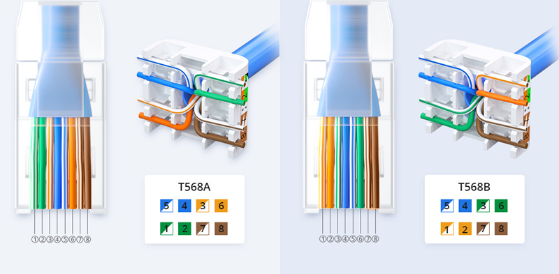

With regard to the two standards, there are two different connectivity forms. If both ends of the patch cords are wired on the basis of one standard, it is a straight-through connection. If not, it is a crossover connection. Some networking applications require a crossover Ethernet cable, which has a T-568A connector on one end and a T-568B connector on the other. This type of cable is typically used for direct computer-to-computer connections when there is no router, hub, or switch available.

Cat6 Cable: Short for Category 6, Cat6 is an Ethernet cable standard defined by the Electronic Industries Association (EIA) and Telecommunications Industry Association (TIA). What is Cat6 cable used for? As the sixth generation of twisted pair Ethernet cabling, Cat6 cable consists of four twisted pairs and is either terminated by an RJ45 or terminated on a patch or a keystone jack. Theoretically, the maximum speed of the Cat6 network cable is 10Gbps.

A single run of Ethernet cable is designed to work at a maximum distance of 100 meters (328 ft). A length longer than that will result in issues such as dropped packets, reduced performance, and loss of signal when deploying Cat6 cable. The max length of a Cat6 cable usually consists of 90 meters (295 ft) of solid "horizontal" cabling between the patch panel and the wall jack, plus 5 meters (16 ft) of stranded patch cable between each jack and the attached device. For 10GBASE-T, an unshielded Cat6 cable should not exceed 55 meters.

Crimping tool: It is a tool that is used to connect RJ45 connector to Cat6 cable

Steps to crimp RJ45 with Cat6 using Crimping tool:

Step 1: **Strip the cable back 1 inch (25 mm) from the end**. Insert the cable into the stripper section of the tool and squeeze it tight. Then, rotate the crimping tool around the cable in a smooth and even motion to create a clean cut. Keep the tool clamped and pull away towards the end of the wire to remove the sheathing.

* The stripping section is a round hole near the handle of the tool.
* The sheathing should come off cleanly, leaving the wires exposed.

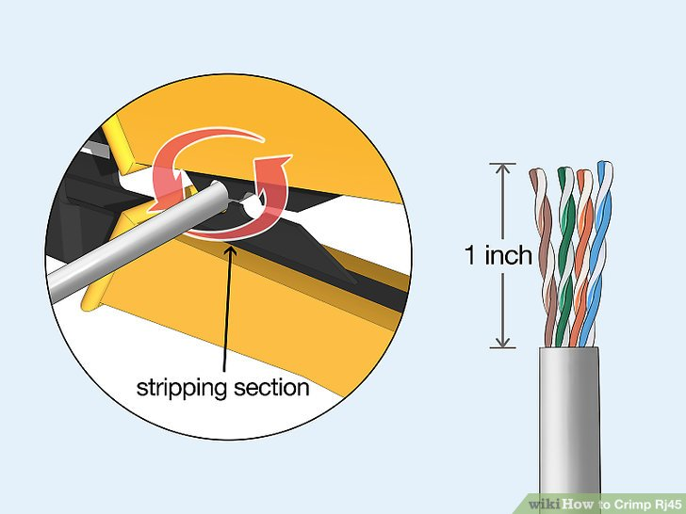

Step 2: **Untwist and straighten the wires inside of the cable.** Inside of the cable you’ll see a bunch of smaller wires twisted together. Separate the twisted wires and straighten them out so they’re easier to sort into the right order.

* Cut off the small plastic wire separator or core so it’s out of the way.
* Don’t cut off or remove any of the wires or you won’t be able to crimp them into the connector.

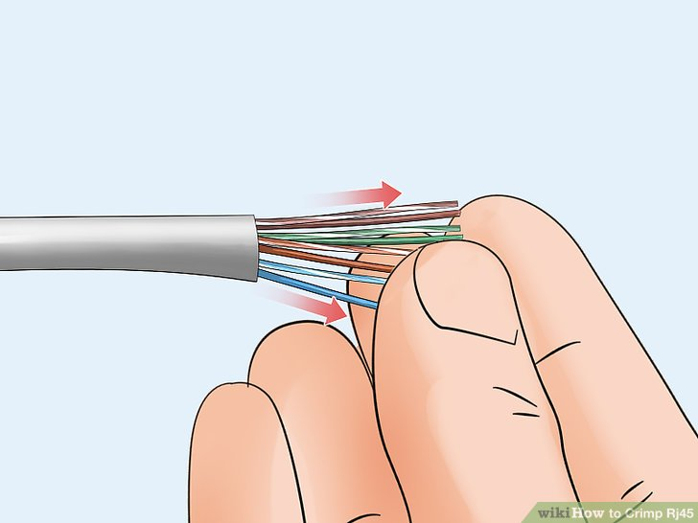

Step 3: **Arrange the wires into the right order.** Use your fingers to put the wires in the correct order so they can be properly crimped. The proper sequence is as follows from left to right: Orange/White, Orange, Green/White, Blue, Blue/White, Green, Brown/White, Brown.

* There are 8 wires in total that need to be arranged in the right sequence.
* Note that the wires labeled Orange/White or Brown/White indicate the small wires that have 2 colors.

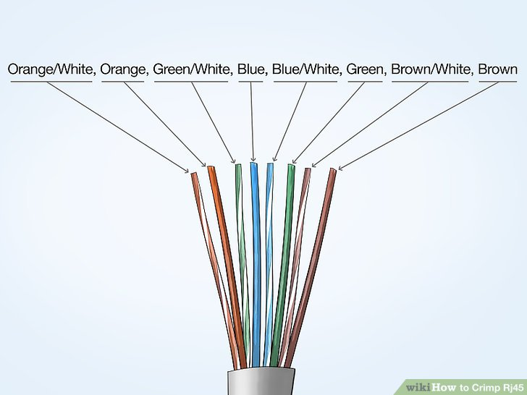

Step 4: **Cut the wires into an even line 1⁄2 inch (13 mm) from sheathing.** Hold the wires with your thumb and index finger to keep them in order. Then, use the cutting section of the crimping tool to cut them into an even line.

* The cutting section of the tool will resemble wire cutters.
* The wires must be in an even line to be crimped into the RJ-45 connector properly. If you cut them in an uneven line, move further down the wires and cut them again.

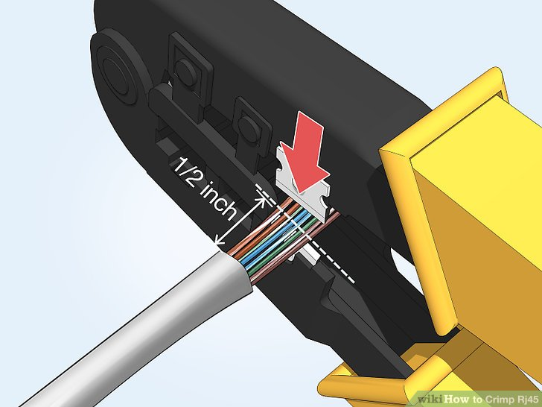

Step 5: **Insert the wires into the RJ-45 connector.** Hold the RJ-45 connector so the clip is on the underside and the small metal pins are facing up. Insert the cable into the connector so that each of the small wires fits into the small grooves in the connector.[[5]](https://www.wikihow.com/Crimp-Rj45#_note-5)

* The sheathing of the cable should fit just inside of the connector so it’s past the base.
* If any of the small wires bend or don’t fit into a groove correctly, take the cable out and straighten the wires with your fingers before trying again.
* The wires must be inserted in the correct order and each wire must fit into a groove before you crimp the connector.

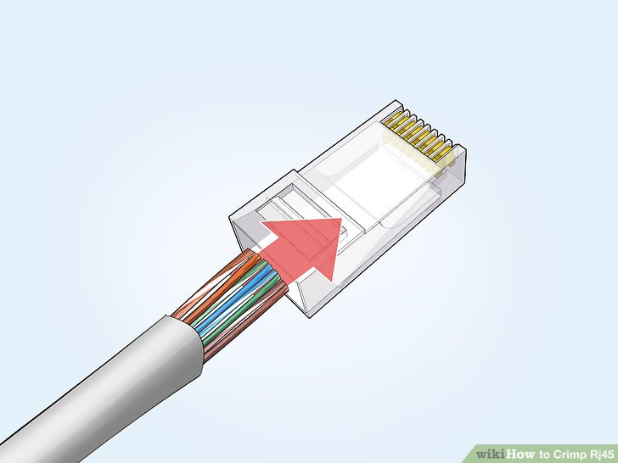

Step 6: **Stick the connector into the crimping part of the tool and squeeze twice.** Insert the connector in the crimping section of the tool until it can’t fit any further. Squeeze the handles to crimp the connector and secure the wires. Release the handles, then squeeze the tool again to make sure all of the pins are pushed down.

* The crimping tool pushes small pins in the grooves down onto the wires to hold and connect them to the RJ-45 connector.

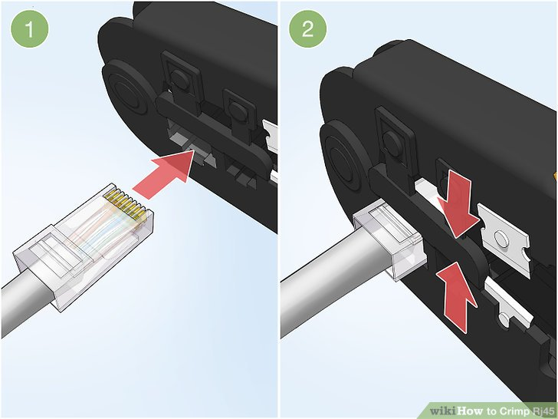

Step 7: **Remove the cable from the tool and check that all of the pins are down.** Take the connector out of the tool and look at the pins to see that they’re all pushed down in an even line. Lightly tug at the connector to make sure it’s attached to the cable.

* If any of the pins aren’t pushed down, put the wire back into the crimping tool and crimp it again.

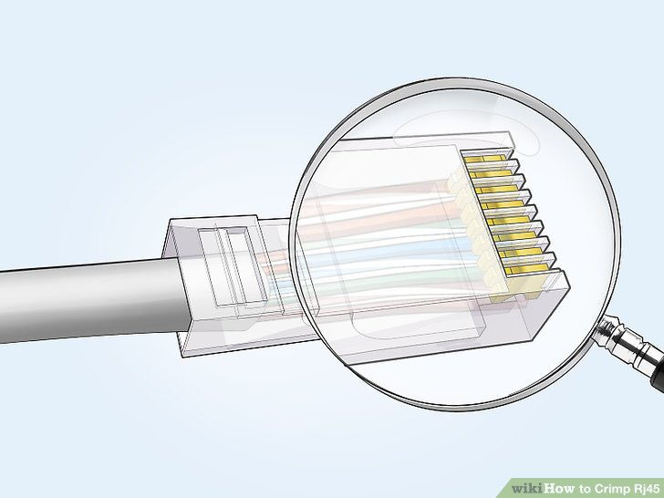

Conclusion: We have successfully learnt crimping/cabling of RJ45 connector to Cat6 Cable using crimping tool by carefully following the above given steps.